**Activity 14.3 - Mohammed Abdin**

**Submission Instructions:**

Your submission for this assignment should be a Word document that includes the following screenshots, each labelled for the step that the screenshot represents:

1. Provide a screenshot showing that you successfully ran the docker network create command to create the Docker network called myCDCNetwork.

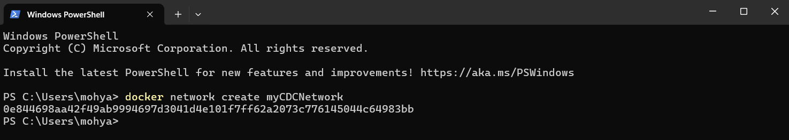

1. Provide a screenshot to show that the Activity14_3 folder in VS Code.

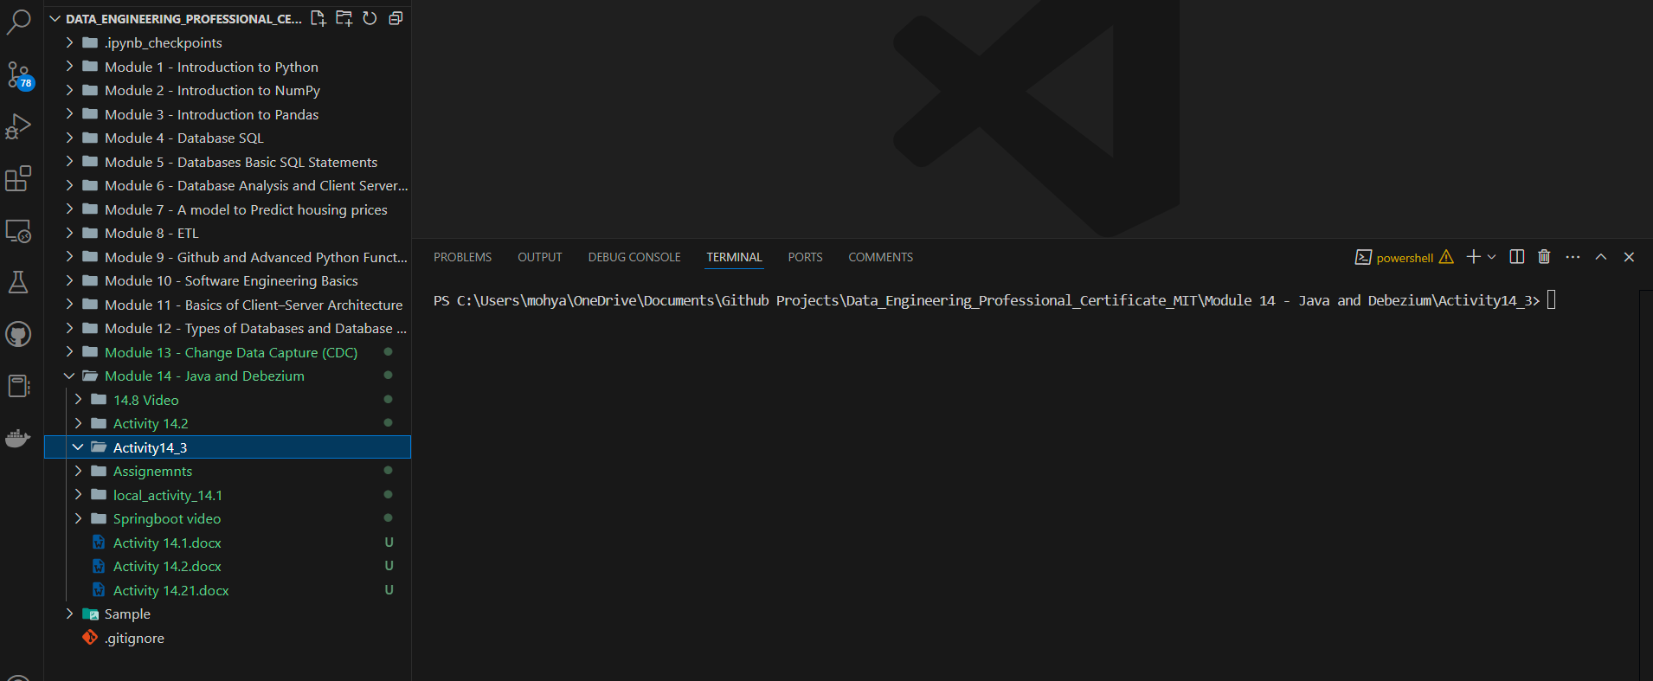

1. Provide a screenshot to show that you added the customer.sql file.

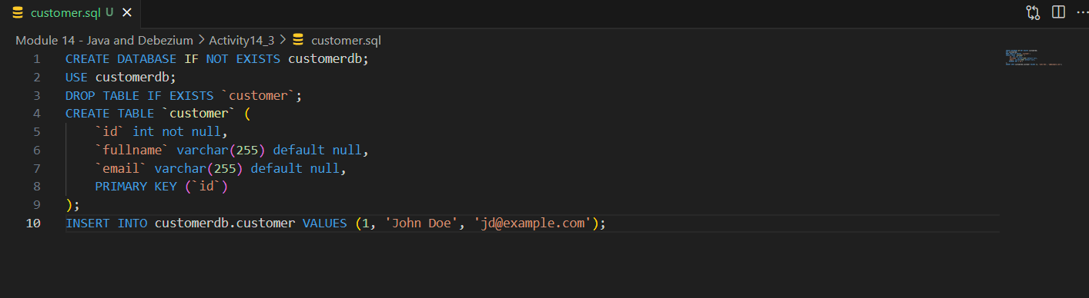

1. Provide a screenshot to show that you successfully added the file called Dockerfile.

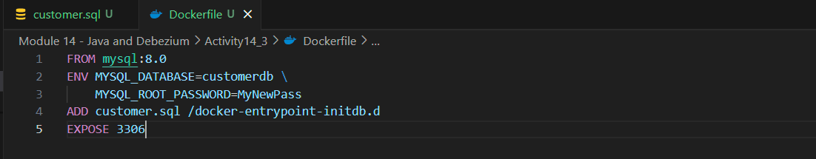

1. Provide a screenshot to show that there are no Docker *containers* running.

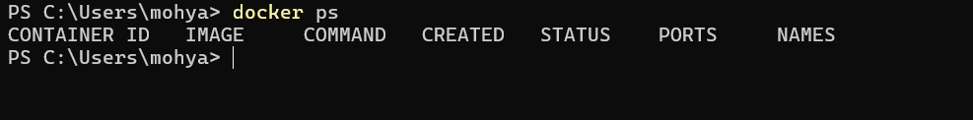

1. Provide a screenshot to show that you successfully executed the command to create a MySQL Docker *image*.

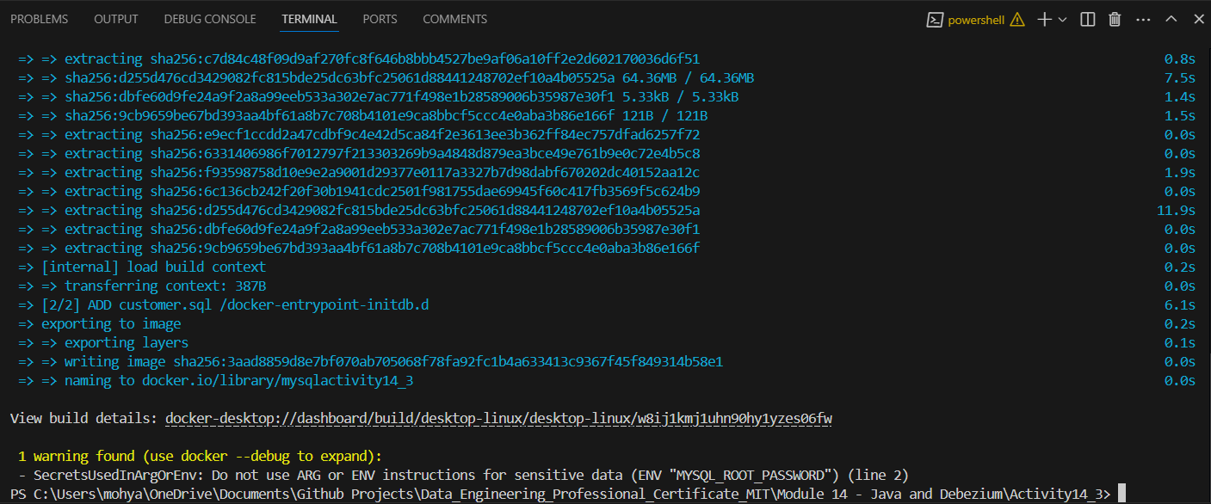

1. Provide a screenshot to show that you successfully executed the command to create a MySQL Docker *container* and associate it to the myCDCNetwork.



1. Provide a screenshot of your Docker Desktop showing the mysqlserver *container* running.

